**Zhumagali Kanat IT2-2003**

**e**

**Practice 7**

1. Create and invoke the GET_JOB function to return a job title.

* + - 1. Create and compile a function called GET_JOB to return a job title.
      2. Call the created function from an anonymous block for the SA_REP job ID and print the result.

create or replace function get_job(j_id jobs.job_id%type) return jobs.job_title%type is j_title jobs.job_title%type;

begin

select job_title into j_title from jobs where job_id = j_id;

return j_title;

end get_job;

declare

job_t jobs.job_title%type;

cursor j_cursor is select e.last_name, e.salary, j.job_title from employees e inner join jobs j on e.job_id = j.job_id where j.job_title = job_t;

begin

job_t := get_job('SA_REP');

for j_rec in j_cursor loop

dbms_output.put_line('last name: ' || j_rec.last_name || ' salary: ' || j_rec.salary || ' j title: ' || j_rec.job_title);

end loop;

end;

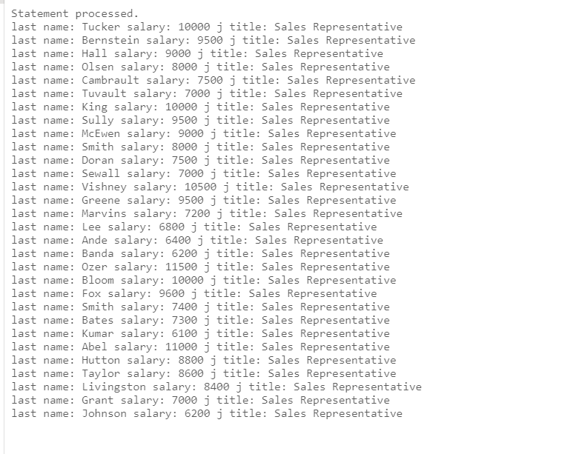

2. Create a function called GET_ANNUAL_COMP to return the annual salary computed from an employee’s monthly salary and commission passed as parameters.

a. Create the function, which accepts parameter values for the monthly salary and commission. Either or both values passed can be NULL, but the function should still return a non-NULL annual salary. Use the following basic formula to calculate the annual salary:  
 (salary*12) + (commission_pct*salary*12)

b. Use the function in a SELECT statement against the EMPLOYEES table for employees in department 30.

create or replace function get_annual_comp (salary employees.salary%type, commission_pct employees.commission_pct%type) return employees.salary%type is com_pct employees.commission_pct%type;

begin

if commission_pct is null then

com_pct := 0.5;

return ((salary*12) + (com_pct*salary*12));

else return ((salary*12) + (commission_pct*salary*12));

end if;

end get_annual_comp;

select last_name, salary, get_annual_comp(salary, commission_pct ) from employees where department_id = 30

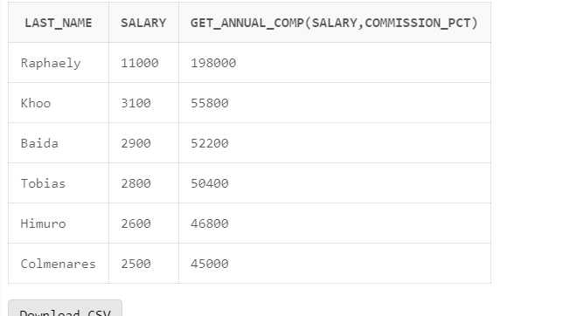

3. Create a procedure, ADD_EMPLOYEE, to insert a new employee into the EMPLOYEES table. The procedure should call a VALID_DEPTID function to check whether the department ID specified for the new employee exists in the DEPARTMENTS table.

a. Create a function called VALID_DEPTID to validate a specified department ID and return a BOOLEAN value of TRUE if the department exists.

b. Create the ADD_EMPLOYEE procedure to add an employee to the EMPLOYEES table. The row should be added to the EMPLOYEES table if the VALID_DEPTID function returns TRUE; otherwise, alert the user with an appropriate message. Provide the following parameters:

* + - * + first_name
        + last_name
        + email
        + job: Use ‘SA_REP’ as the default
        + mgr: Use 145 as the default
        + sal: Use 1000 as the default
        + comm: Use 0 as the default
        + deptid: Use 30 as the default
        + Use the EMPLOYEES_SEQ sequence to set the employee_id column
        + Set the hire_date column to TRUNC(SYSDATE)
      1. Call ADD_EMPLOYEE for the name Jane Harris in department 15, leaving other parameters with their default values. What is the result?
      2. Add another employee named Joe Harris in department 80, leaving remaining parameters with their default values. What is the result?

create or replace function valid_deptid (department_id departments.department_id%type ) return boolean is

begin

if department_id is null then return false;

else return true;

end if;

end valid_deptid;

create or replace procedure add_employee(

first_name employees.first_name%TYPE,

last_name employees.last_name%TYPE,

email employees.email%TYPE := 'mail',

job employees.job_id%TYPE := 'SA_REP',

mgr employees.manager_id%TYPE := 145,

sal employees.salary%TYPE := 100,

comm employees.commission_pct%TYPE := 0,

deptid employees.department_id%TYPE := 30

)

is

begin

IF valid_deptid(deptid) then

insert into employees(employee_id, first_name, last_name, email, hire_date, job_id, salary, commission_pct, manager_id, department_id)

values (EMPLOYEES_SEQ.nextval, first_name, last_name, email, TRUNC(SYSDATE), job, sal, comm, mgr, deptid);

DBMS_OUTPUT.PUT_LINE('TRUE');

else

DBMS_OUTPUT.PUT_LINE('FALSE');

end if;

end;

execute add_employee('Jane', 'Haris', deptid => 15);

EXECUTE add_employee(first_name => 'Joe', last_name => 'Haris', deptid => 80);

select * from employees where first_name = 'Jane';

select * from employees where first_name = 'Joe';

